**Step # 1 - Create Credentials to connect to ACR from Jenkins**

* Go to Azure Portal console, go to the container registry.
* Go to Settings--> Access keys.
* Get the username and password.

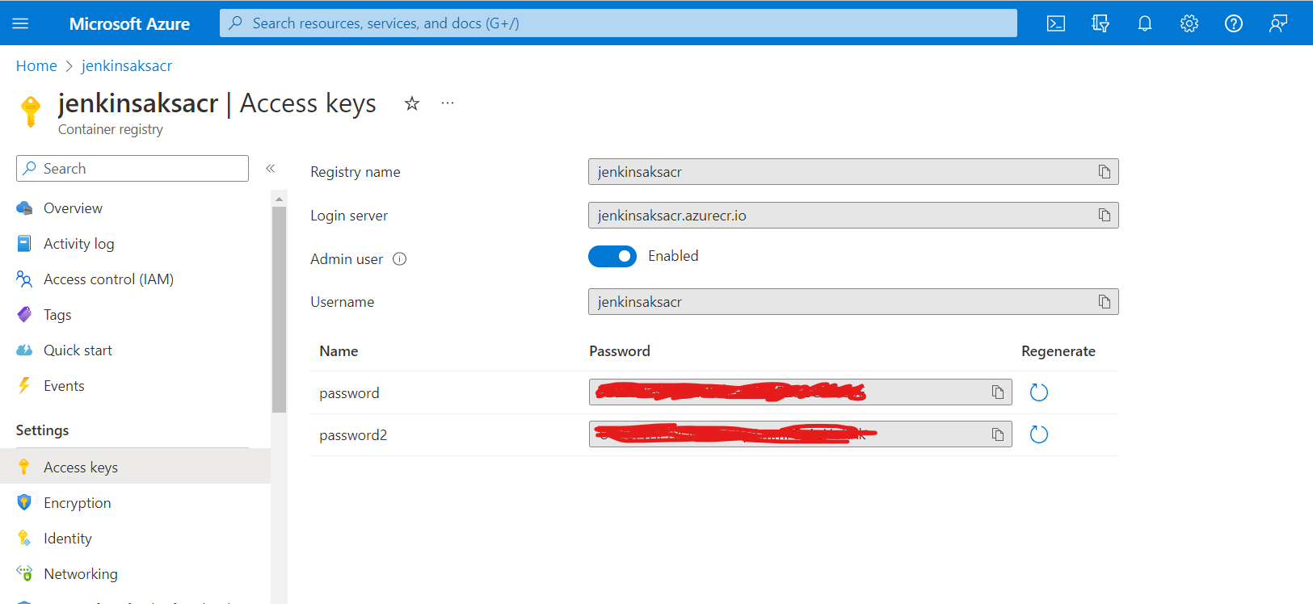

Go to Jenkins-> Manage Jenkins. Create credentials.

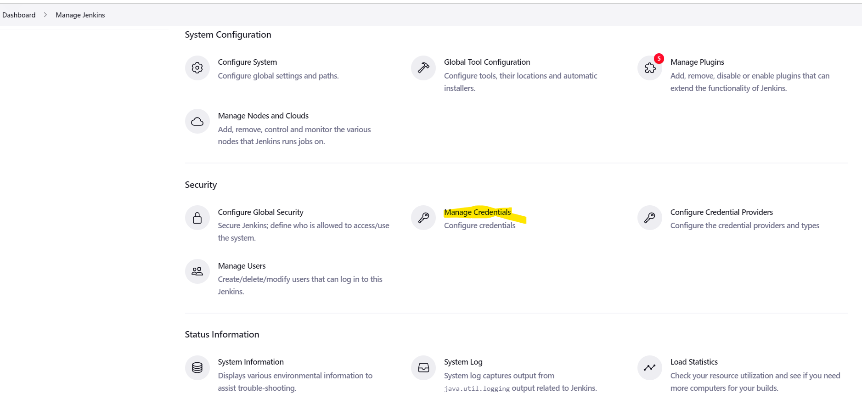

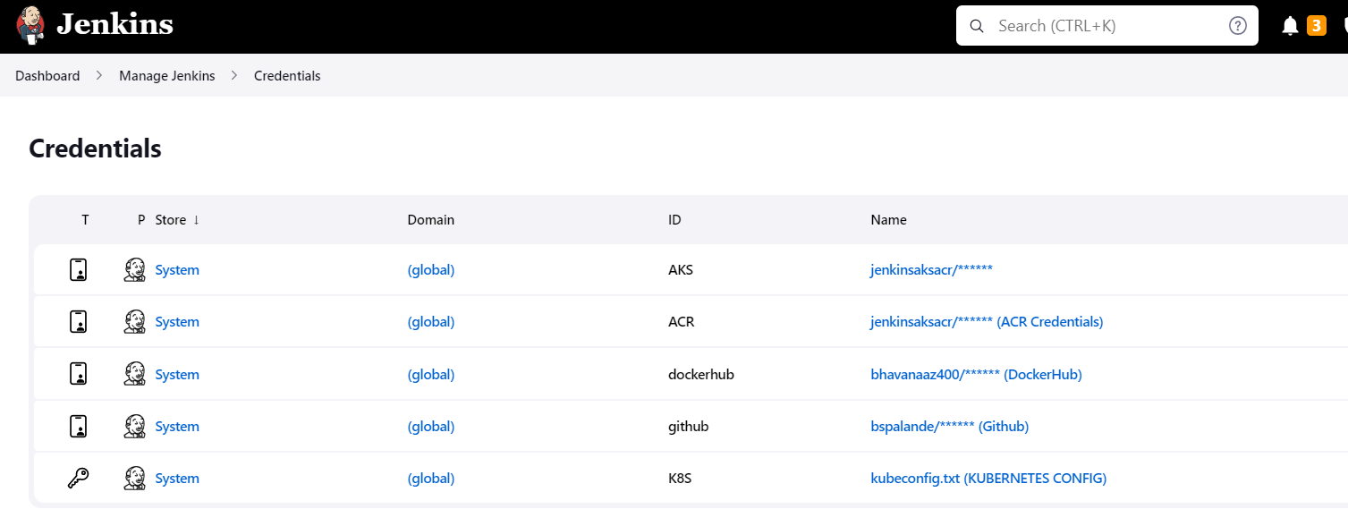

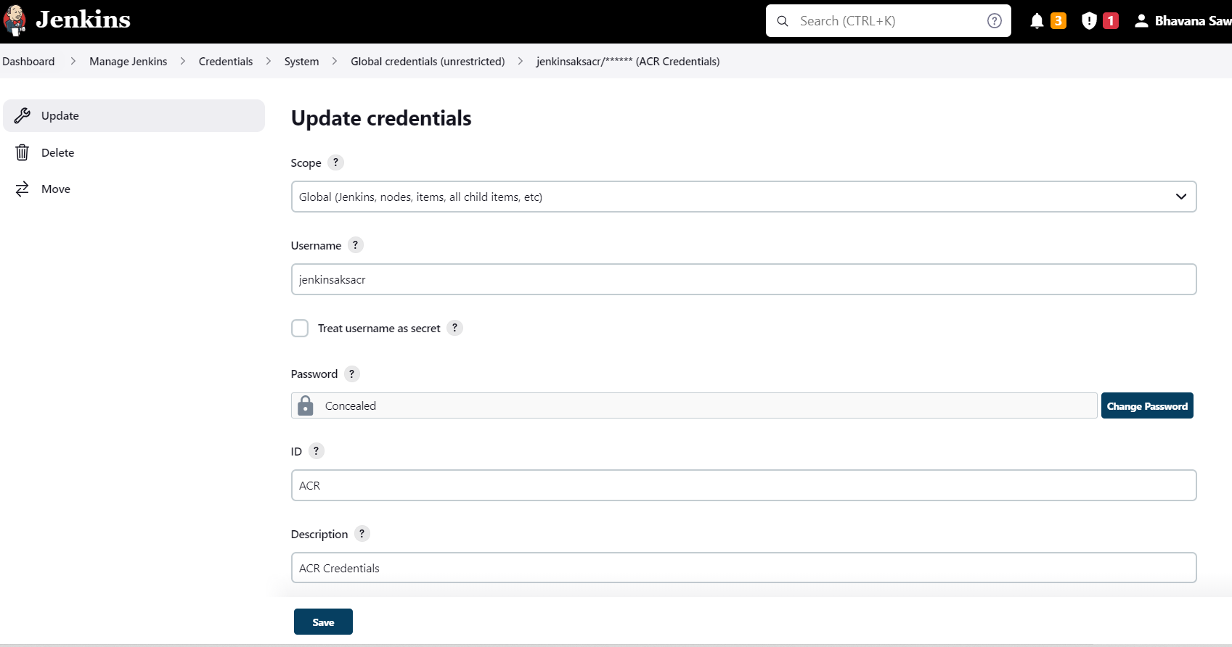

Enter ID as ACR and enter some text for description and Save.

### **Step #2 - Create Credentials for connecting to the AKS cluster using Kubeconfig.**

Go to Jenkins UI, click on Credentials.

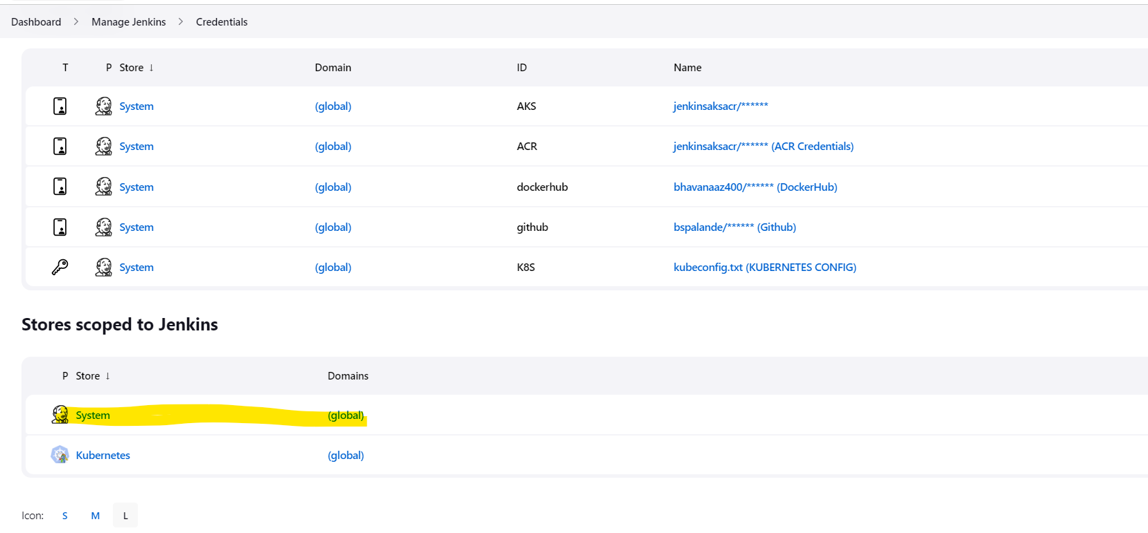

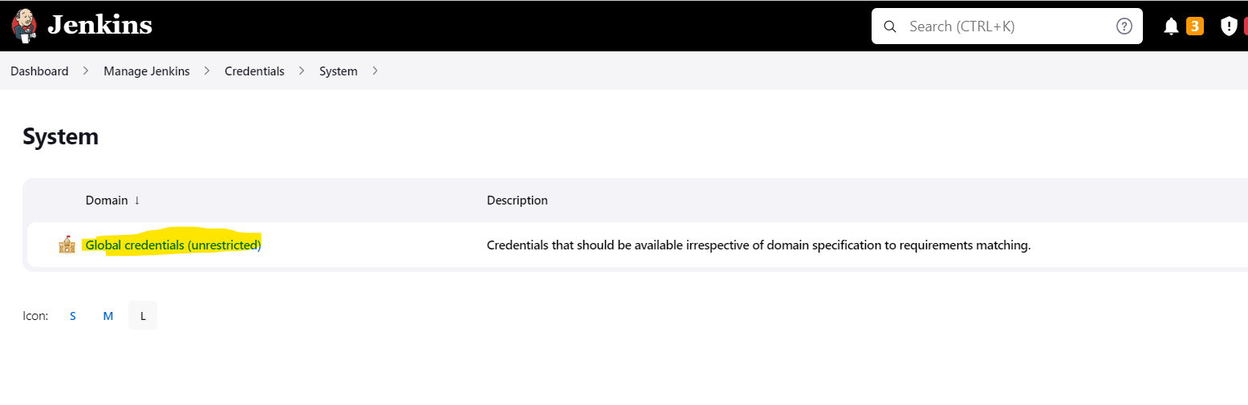

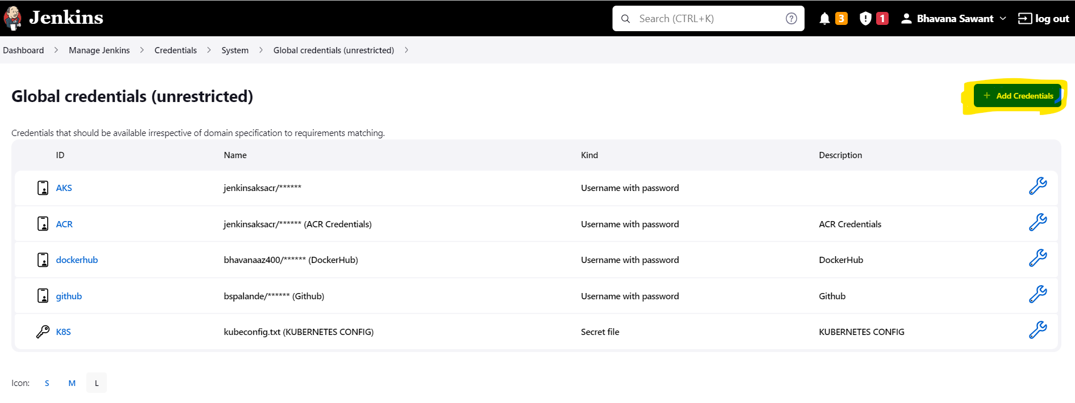

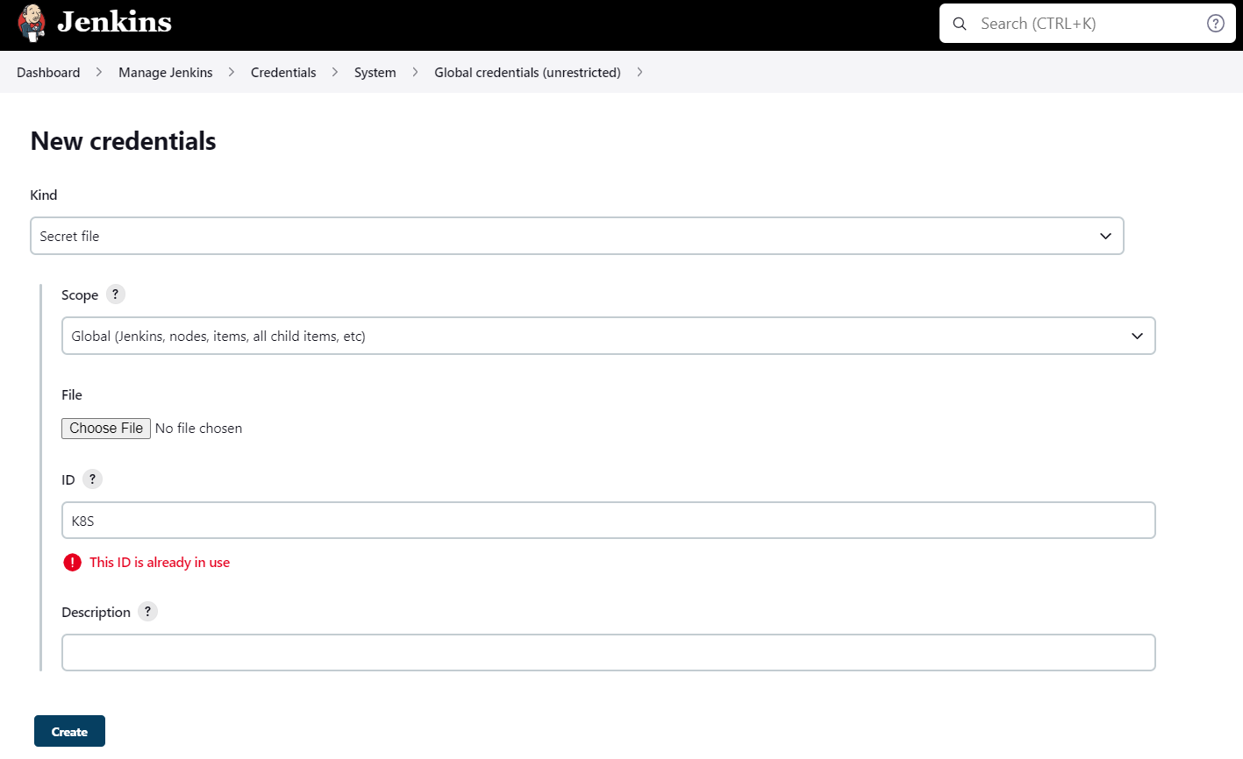

Go to Azure Cloud Shell.

Check if the nodes are working in Cluster.

Kubectl get nodes.

Execute the below command to get kubeconfig info, copy the entire content of the file:

cat ~/.kube/config

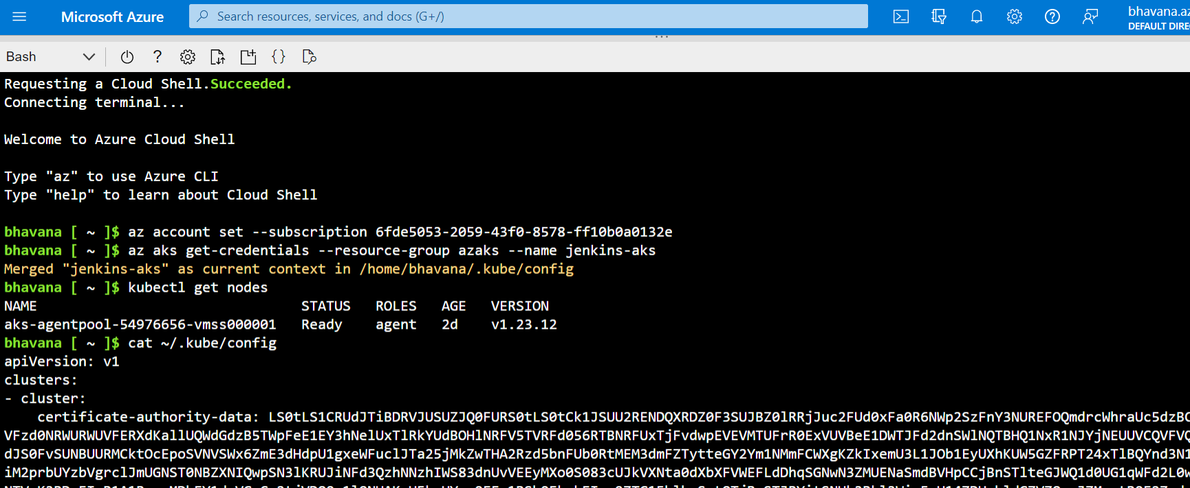

Open your text editor or notepad, copy and paste the entire content and save in a file.

This file will be uploaded for Kubernetes config credential.

### **Step #3 - Create Credentials for docker**

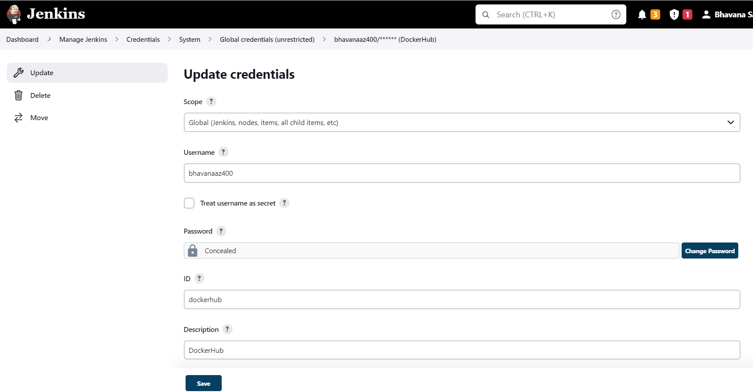

This is your Dockerhub account’s credentials.

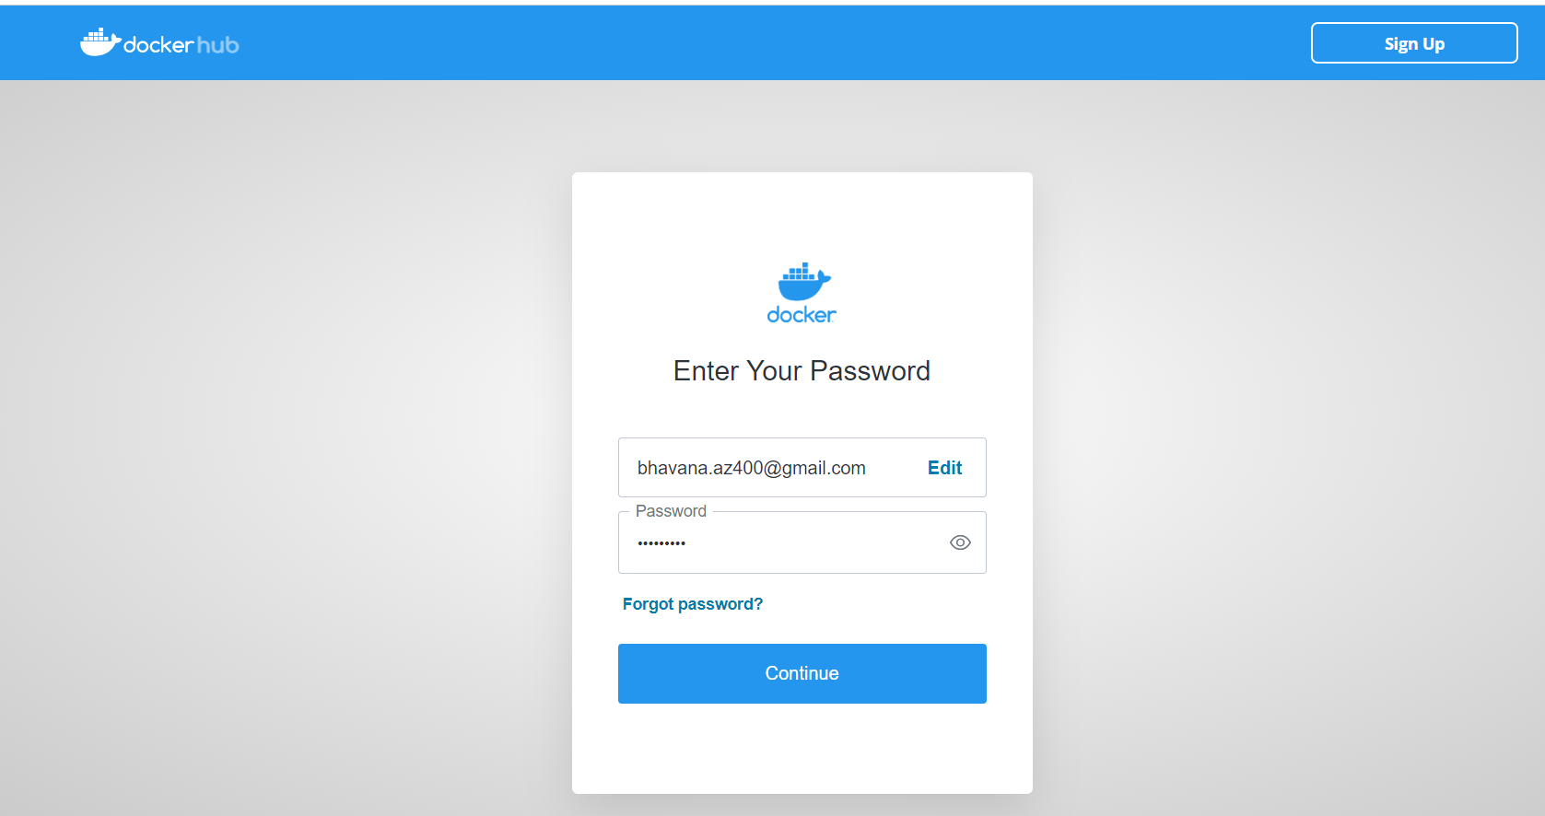

### **Step #4 - Create Credentials for Github**

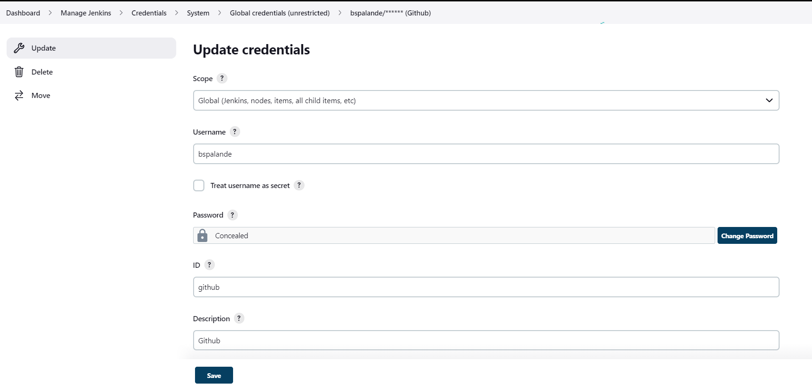

This is your github account’s credentials.

